FM Marsudi: ASEAN Unity and Centrality Key to Regional Stability

Jakarta, 11 July 2023 – Indonesian Foreign Minister Retno Marsudi reaffirmed the importance of ASEAN’s unity and centrality to maintain peace and stability in the region while chairing the plenary session of the 56th ASEAN Foreign Ministers Meeting (AMM) in Jakarta (11/7).

“For more than five decades, Southeast Asia has enjoyed peace, stability, and prosperity. We cannot take this for granted. Peace does not fall from the sky. It is a result of a systematic effort to build an inclusive regional architecture, anchored in the habit of dialogue and collaboration based on the principles of the UN Charter, ASEAN Charter, and international law," she further stated.

Peace and stability in the region, therefore, must be maintained, especially amidst increasingly complex global situation. ASEAN must be able to navigate regional and global dynamics and continue to instill the paradigm of collaboration.

"We can only achieve this if we maintain ASEAN unity and centrality," Minister said.

In this regard, FM Marsudi proposed two things to be advanced:

First, maintaining ASEAN's credibility. This means that ASEAN Charter must be consistently implemented, including in the decision-making process during emergency situations.

"We must prove that united we can address existing challenges, while also ready to anticipate and respond to future challenges. That is why long-term ASEAN Vision is so crucial," she said.

Second, ASEAN must remain in the driver seat in navigating regional dynamics. ASEAN needs to send a clear message that it will never become a proxy in great powers’ rivalry.

"The Treaty of Amity and Cooperation must be abided by all. ASEAN must be at the forefront in building inclusive regional architecture," Marsudi said.

FM Marsudi added that mini-lateralism must support peace, stability, and prosperity in the Indo-Pacific. ASEAN must also expand its relationship with the Pacific region and ensure its inclusiveness.

FM Marsudi further conveyed Indonesia's proposal to initiate ASEAN Concord IV, which will become the main reference for ASEAN's Post 2025 Vision. The core elements of the Concord IV will be further discussed to be adopted at the 43rd ASEAN Summit. ASEAN member states welcomed this initiative.
At the meeting, ASEAN Secretary General appreciated Indonesia's leadership in initiating the ASEAN Maritime Outlook which will be issued at the ASEAN Maritime Forum in August.

The meeting also discussed the increasing requests from countries to accede to the TAC. The meeting further approved Serbia's application for the TAC accession. Meanwhile, Saudi Arabia is scheduled to sign the TAC on the sidelines of the 56th AMM PMC meeting. The signing of the TAC by Panama, Spain, and Mexico is tentatively planned to take place at the 43rd ASEAN Summit.

On ASEAN’s external relations, ASEAN’s Foreign Ministers agreed on the following:

i) The initiative on inter-secretariat cooperation between ASEAN - Pacific Island Forum (PIF) and ASEAN – Indian Ocean Rim Association (IORA).

ii) The establishment of the ASEAN - US Centre.

iii) The application of South Africa and Morocco (in principle) as Sectoral Dialogue Partners (SDPs) of ASEAN.

iv) ASEAN - GCC Summit in Riyadh in October 2023

v) ASEAN - GCC Foreign Ministers’ Meeting on the sidelines of the UN General Assembly in September 2023

vi) ASEAN - CELAC Foreign Ministers Meeting on the sidelines of the UN General Assembly in September 2023

vii) ASEAN - Japan Summit in September 2023

The Plenary Meeting adopted the ASEAN Maritime Outlook initiated by Indonesia, the Concept Note on ASEAN-PIF Cooperation, and Concept Note on ASEAN-IORA Cooperation.

***

For further information, please contact the following:

Director for Information and Media of the Ministry of Foreign Affairs - Hartyo Harkomoyo (+62811831899)

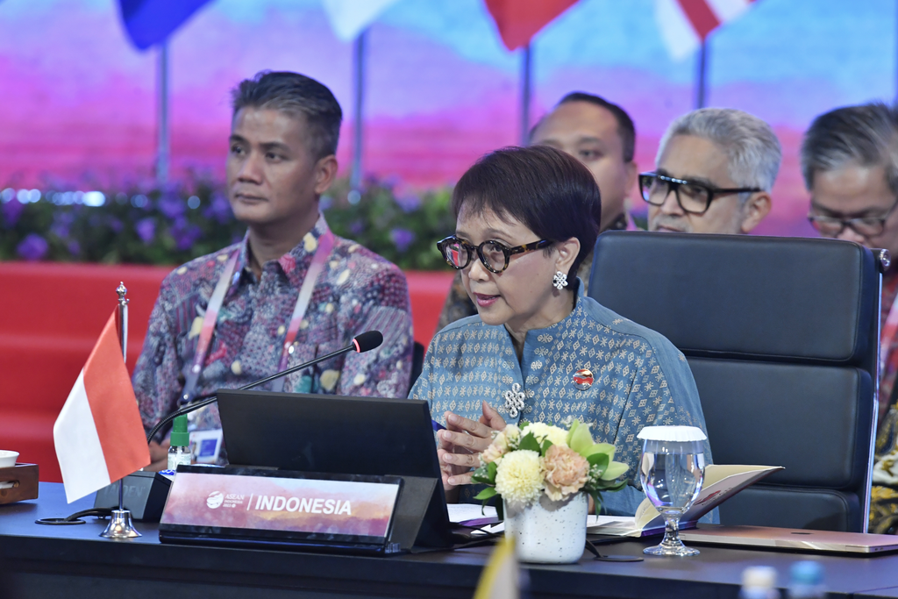

Indonesian Foreign Minister Retno Marsudi reaffirmed the importance of ASEAN’s unity and centrality to maintain peace and stability in the region while chairing the plenary session of the 56th ASEAN Foreign Ministers Meeting (AMM) in Jakarta (11/7).

